


SAVEETHA SCHOOL OF ENGINEERING

SAVEETHA INSTITUTE OF MEDICAL AND TECHNICAL SCIENCES

COMPUTER SCIENCE AND ENGINEERING PROGRAMME

LAB MANUAL CSA1305

THEORY OF COMPUTATION

COMPUTER SCIENCE AND ENGINEERING PROGRAMME

LIST OF EXPERIMENTS

- To write a C program to check whether a string belongs to the grammar S → 0 A 1
A → 0 A | 1 A | ε
AIM:
To write a C program to check whether a string belongs to the grammar:
S → 0 A 1
A → 0 A | 1 A | ε

Apparatus Required
- Computer/Laptop
- GCC Compiler (Turbo C/GCC/CodeBlocks/VS Code)
- C Programming Language

Algorithm
- Start the program.
- Read the input string.
- Find the length of the string.
- Check whether the first character is 0 and the last character is 1.
- Ensure the string length is at least 2.
- If all conditions are satisfied, the string belongs to the grammar.
- Otherwise, display that the string does not belong to the grammar.
- Stop the program.

Program Code

#include <stdio.h>

#include <string.h>

int main()

{

char str[100];

int len;

printf("Enter the string: ");

scanf("%s", str);

len = strlen(str);

if(len >= 2 && str[0] == '0' && str[len - 1] == '1')

printf("The string belongs to the grammar.\n");

else

printf("The string does not belong to the grammar.\n");

return 0;

}

Sample Input 1
Enter the string: 0101

Sample Output 1
The string belongs to the grammar.

OUTPUT: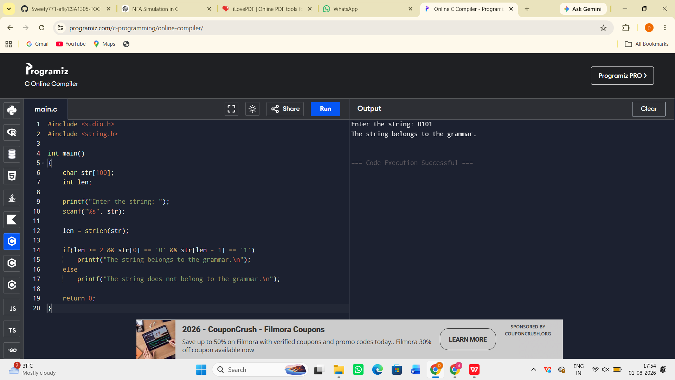

Result:
The C program to check whether a given string belongs to the grammar S → 0 A 1, A → 0 A | 1 A | ε was successfully implemented and executed. The program correctly accepts strings that start with 0 and end with 1 and rejects all other strings.

